BOOK READER XR

# A PROJECT REPORT

## Submitted by

## YASH SHRIVASTAVA

**(2200290140187)**

**VIKASH GUPTA**

**(2200290140177)**

**Submitted in partial fulfilment of the**

**Requirements for the Degree of**

MASTER OF COMPUTER APPLICATION

## Under the Supervision of

## Dr. Sangeeta Arora

## Associate Professor



**Submitted to**

**Department Of Computer Applications**

**KIET Group of Institutions, Ghaziabad Uttar Pradesh-201206**

**(Jan-2023)**

**DECLARATION**

I hereby declare that the work presented in this report entitled “Book Reader XR”, was carried out by me. I have not submitted the matter embodied in this report for the award of any other degree or diploma of any other University or Institute. I have given due credit to the original authors/sources for all the words, ideas, diagrams, graphics, computer programs, experiments, results, that are not my original contribution. I have used quotation marks to identify verbatim sentences and given credit to the original authors/sources.

I affirm that no portion of my work is plagiarized, and the experiments and results reported in the report are not manipulated. In the event of a complaint of plagiarism and the manipulation of the experiments and results, I shall be fully responsible and answerable.

Name : Yash Shrivastava (2200290140187)

Vikash Gupta (2200290140187)

**(Candidate Signature)**

# CERTIFICATE

Certified that Yash Shrivastava **2200290140187** have carried out the project work having “Book Reader XR"for Master of Computer Applications from Dr. A.P.J. Abdul Kalam Technical University (AKTU**)**, Lucknow under my supervision. The project report embodies original work, and studies are carried out by the student himself / herself and the contents of the project report do not form the basis for the award of any other degree to the candidate or to anybody else from this or any other University/Institution.

**Date:**

**Yash Shrivastava (2200290140187)**

**Vikash Gupta (2200290140177)**

This is to certify that the above statement made by the candidate is correct to the best of my knowledge.

Date:

**Dr. Sangeeta Arora**

**Associate Professor**

**Department of Computer Applications KIET Group of Institutions, Ghaziabad**

**Signature of Internal Examiner Signature of External Examiner**

**Dr. Arun Kumar Tripathi**

**Head, Department of Computer Applications KIET Group of Institutions, Ghaziabad**

# ABSTRACT

This project presents an innovative augmented reality (AR) application designed to enhance the user experience of exploring a college brochure. By leveraging image recognition technology, the project enables users to scan the books using their smartphone's camera, which then detects predefined image targets within the brochure. Once an image target is detected, the application overlays text and other options such as web searching, download book related to the specific target, creating an immersive and interactive experience for users.

The project employs AR technology to bridge the gap between the physical and digital worlds, offering users a unique way to interact with the books. Through the integration of computer vision algorithms, the application recognizes and tracks image targets in real-time, providing seamless and accurate detection. Upon successful detection, the application renders text and enable other options (download, web search, etc.) that align with the content associated with the respective target.

Through the implementation of this augmented reality project, users can gain a deeper understanding of the book content by exploring additional digital resources and interactive elements. The application showcases the potential of augmented reality technology in enhancing traditional marketing materials, providing a more engaging and immersive experience for potential students and stakeholders.

Keywords: Augmented reality, Image recognition, Image tracking, Computer vision, web search, Smartphone application.

# ACKNOWLEDGEMENT

Success in life is never attained single-handedly. My deepest gratitude goes to my thesis supervisor, **Dr. Sangeeta Arora** for her guidance, help and encouragement throughout my research work. Their enlightening ideas, comments, and suggestions.

Words are not enough to express my gratitude to **Dr. Arun Kumar Tripathi**, Professor and Head, Department of Computer Applications, for his insightful comments and administrative help at various occasions.

Fortunately, I have many understanding friends, who have helped me a lot on many critical conditions.

Finally, my sincere thanks go to my family members and all those who have directly and indirectly provided me with moral support and other kind of help. Without their support, completion of this work would not have been possible in time. They keep my life filled with enjoyment and happiness.

Yash Shrivastava

Vikash Gupta

**TABLE OF CONTENTS**

|  |  |  |  |
| --- | --- | --- | --- |
|  | Declaration  Certificate |  | ii iii |
|  | Abstract |  | iv |
|  | Acknowledgement |  | v |
|  | Table of Contents |  | vi-vii |
|  | List of Figures |  | viii |
|  | List of Tables |  | ix |
| 1 | Introduction |  | 1-3 |
|  | 1.1 | Overview | 1-2 |
|  | 1.2 | Objective | 2 |
|  | 1.3 | Project Features | 2-3 |
| 2 | Literature Review |  | 4-12 |
|  | 2.1 | Domain Specific | 4 |
|  | 2.2 | Discovering the magic of extended reality | 4-6 |
|  | 2.3 | Literature Review | 7-12 |
| 3 | Feasibility Study |  | 13-18 |
|  | 3.1 | Operational Feasibility | 13-14 |
|  | 3.2 | Technical feasibility | 14-15 |
|  | 3.3 | Economical Feasibility | 15-16 |
|  | 3.4 | Behavioral Feasibility | 17-18 |
| 4 | Requirement Analysis |  | 19-22 |
|  | 4.1 | Introduction | 19-20 |
|  | 4.2 | Scrum Methodologies | 19-20 |
|  | 4.3 | Functional Requirement | 20 |
|  | 4.4 | Non-Functional Requirement | 20-21 |
|  | 4.5 | Software Requirement | 22 |
|  | 4.6 | Hardware Requirement | 22 |

|  |  |  |  |
| --- | --- | --- | --- |
| 5 | System Architecture and Design |  | 23-30 |
|  | 5.1 | Unity and Vuforia SDK Integration | 23-24 |
|  | 5.2 | Image Recognition and Tracking | 25-27 |
|  | 5.3 | Content Management and Rendering | 28-29 |
|  | 5.4 | User Interface and Design Compatibility | 29-30 |
| 6 | Implementation and Result |  | 31-37 |
|  | 6.2 | Project Structure and Organization | 31-32 |
|  | 6.2 | Integration and Content Management | 32 |
|  | 6.3 | Actions and Scripting | 33 |
|  | 6.4 | Testing | 33-37 |
| 7 | Bibliography |  | 38-39 |

**LIST OF FIGURES**

|  |  |  |  |
| --- | --- | --- | --- |
| **Figure No.** | **Name of Figure** | **Page No.** | |
| 2.1 | Reality-Virtuality Continuum |  | 5 |
| 5.1 | KIET Brochure Database |  | 25 |
| 5.2 | Image Target before feature extraction |  | 26 |
| 5.3 | Extracted Feature from Image target |  | 27 |
| 6.1 | File Organization |  | 32 |
| 6.2 | KIET Brochure Image |  | 34 |
| 6.3 | Vertical image target test of Augmented object in Brochure |  | 35 |
| 6.4 | Horizontal image target test of Augmented object in Brochure | | 36 |
| 6.5 | When image target is tilted |  | 37 |

**LIST OF TABLE**

|  |  |  |
| --- | --- | --- |
| **Figure No.** | **Name of Figure** | **Page No.** |
| 4.1 | Software Requirement for Brochure XR | 22 |
| 4.2 | Hardware Requirement for Brochure XR | 22 |

**CHAPTER 1 INTRODUCTION**

* 1. **OVERVIEW**

The field of Augmented Reality (AR) has gained significant attention in recent years, offering exciting possibilities for enhancing user experiences and transforming various industries. This project focuses on the application of AR technology in the domain of college brochures, aiming to provide an interactive and immersive experience for potential students and stakeholders. By leveraging image recognition and tracking algorithms, the project enables users to scan the college brochure using their smartphone's camera, triggering the display of digital objects and videos that correspond to specific image targets within the brochure.

In the context of college admissions and marketing, traditional brochures often serve as static and limited sources of information. They fail to fully engage prospective students or convey the dynamic aspects of campus life. However, with the integration of AR technology, college brochures can be transformed into dynamic and interactive platforms, enabling users to explore additional digital resources and access engaging content.

The implementation of AR in college brochures has the potential to revolutionize how institutions communicate their offerings and engage with prospective students. By overlaying virtual objects and videos onto the physical brochure, users can visualize campus facilities, experience virtual tours, access multimedia content showcasing academic programs, and gain insights into student life. This immersive experience goes beyond the limitations of traditional brochures, offering a more personalized and compelling approach to attract and inform potential students.

The project relies on image recognition technology to detect predefined image targets within the college brochure. Once an image target is recognized, the application renders relevant digital objects and plays contextually appropriate videos, providing users with a dynamic and interactive experience. The seamless integration of computer vision algorithms and multimedia elements enables users to access information and visualize campus resources in a user-friendly and intuitive manner.

By developing and implementing this augmented reality project, we aim to showcase the potential of AR technology in the context of college admissions and marketing. The project serves as a proof-of-concept, demonstrating how AR can transform static marketing materials into dynamic and engaging experiences. Additionally, the project opens opportunities for future research and development in utilizing AR to enhance other educational materials and promotional content.

In the following sections of this report, we will delve into the methodology, implementation details, and evaluation of the AR application. We will discuss the technical aspects of image recognition, tracking algorithms, and multimedia integration. Furthermore, we will present the results of user testing and provide insights into the effectiveness and usability of the AR-based college brochure.

Overall, this project aims to contribute to the growing field of AR technology and its application in the domain of college marketing. By creating an engaging and interactive platform for prospective students, the project offers an innovative approach to showcase the unique features and offerings of educational institutions.

# OBJECTIVE

The objective of this project is to develop an augmented reality application that revolutionizes the experience of exploring a college brochure. By leveraging cutting- edge image recognition technology, the project aims to seamlessly merge the physical and digital worlds. When users open the application and scan the college brochure using their smartphone's camera, the app will detect specific image targets within the brochure. Once an image target is recognized, the application will overlay captivating digital objects and videos onto the physical content.

This integration of augmented content will enhance the brochure's static information, offering users an interactive and immersive journey. The application will prioritize accuracy and reliability in detecting image targets, ensuring a smooth and seamless user experience. It will also provide the capability to play relevant videos based on the recognized targets, providing users with additional information and promotional material about the college. A user-friendly interface will be designed to enable intuitive interaction with the augmented reality features, allowing users to effortlessly navigate through the brochure and digital content.

The application will be optimized for performance and stability, minimizing any latency or glitches during image recognition and content rendering. Compatibility with both iOS and Android platforms will be considered, ensuring broad accessibility for users. By achieving these objectives, the augmented reality project will transform the way users engage with college brochures, creating an innovative and captivating experience that showcases the college's offerings in a unique and technologically advanced manner.

# PROJECT FEATURE

It One of the key features of this augmented reality project is its advanced image recognition technology. The application will utilize state-of-the-art algorithms to accurately detect predefined image targets within the college brochure when viewed through a smartphone's camera. This feature ensures seamless and precise recognition of the specific images, allowing for a smooth integration of digital content.

Another notable feature is the overlaying of digital objects onto the recognized image targets in real-time. The application will seamlessly integrate 3D models, animations, and other digital elements onto the physical brochure, enhancing the static content and bringing it to life. Users will be able to interact with and explore these digital objects, creating an immersive and interactive experience.

The project also includes the capability to play relevant videos based on specific image targets. When the camera detects an image target, the application will initiate the playback of videos that provide additional information, such as virtual tours of campus facilities, interviews with faculty members, or student testimonials. This feature adds a dynamic and informative element to the brochure, allowing users to gain deeper insights into the college's offerings.

The user-friendly interface is another prominent feature of the project. The application will be designed with intuitive navigation and smooth transitions between the physical brochure and the augmented reality content. Users will have the ability to easily switch between different image targets and access various digital elements without any confusion or technical difficulties, ensuring a seamless and enjoyable user experience.

Additionally, the project will prioritize performance and stability. The application will be optimized to provide smooth and real-time rendering of the digital content, minimizing latency or glitches during image recognition and content playback. This feature ensures that users can interact with the augmented reality experience without any interruptions, enhancing their overall satisfaction.

Overall, the project's feature set, including advanced image recognition, real-time overlay of digital objects, video playback, user-friendly interface, and performance optimization, work together to create an immersive and engaging augmented reality experience within the college brochure, providing users with a unique and interactive way to explore and connect with the college's offerings.

**CHAPTER 2**

**LITERATURE REVIEW**

* 1. **DOMAIN SPECIFIC**

Literature survey is a very important step in the software development process. Before building any new tool, we need to check the time factor, economy and company strength. When these things are fulfilled, at that point following stages is to figure out which working framework and language can be utilized for building up the device. A lot of help is required for building the tool, internal as well as external. Senior programmers can help and provide this support to the developers from various sources like research papers, books or online websites. Before building the framework the above thoughts are considered for building up the proposed framework.

# DISCOVERING THE MAGIC OF EXTENDED REALITY

Extended Reality (XR) is an emerging and transformative technology that encompasses a spectrum of immersive experiences, blending the physical and virtual worlds. XR refers to a collection of technologies that include virtual reality (VR), augmented reality (AR), and mixed reality (MR). It enables users to engage with digital content in a more interactive and realistic manner, opening endless possibilities for various industries and applications.

* + - **VIRTUAL REALITY**

Virtual reality (VR) transports users to entirely computer-generated environments, immersing them in a simulated reality. With the use of specialized headsets and controllers, users can explore and interact with virtual worlds, experiencing a heightened sense of presence and immersion.

* + - **AUGMENTED REALITY**

Augmented reality (AR) overlays digital content onto the real world, enhancing the user's perception and interaction with their surroundings. AR can be experienced through smartphones, tablets, smart glasses, or specialized headsets, allowing users to see and interact with virtual objects and information while still being aware of the physical environment.

* + - **MIXED REALITY**

Mixed reality (MR) combines elements of both virtual reality and augmented reality, seamlessly integrating virtual objects into the real world and enabling users to interact with both physical and digital entities in a cohesive and interactive manner. MR experiences often involve the use of headsets or smart glasses that offer spatial mapping and precise tracking capabilities.

XR technologies are rapidly evolving and finding applications in a wide range of industries, including gaming, entertainment, education, healthcare, architecture, engineering, and many more. They have the potential to revolutionize how we learn, work, communicate, and interact with our environment. From immersive training simulations and virtual travel experiences to interactive design and visualization tools, XR is reshaping the way we perceive and engage with digital content.

# REALITY VIRTUALITY CONTINUUM

The scale between the reality, virtual reality (virtuality) and Virtual, first introduced by Paul Milgram. The area between the extremes of virtual and reality is called mixed reality. A place where there is both augmented reality and augmented-virtuality.

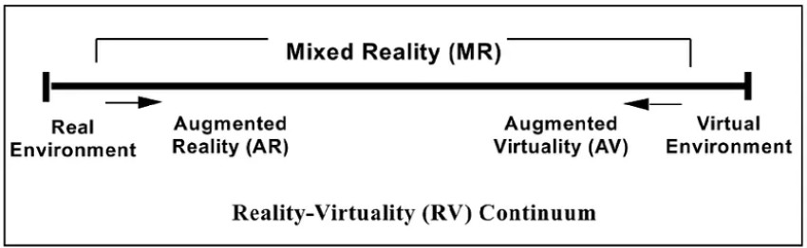

# VUFORIA SDK

**Fig. 2.1 Reality-Virtuality Continuum**

Vuforia SDK is a software development kit (SDK) provided by PTC (formerly Qualcomm), specifically designed for developing augmented reality (AR) applications. It offers a comprehensive set of tools and APIs that enable developers to create AR experiences by integrating computer vision capabilities into their applications.

Key features of Vuforia SDK include:

* + - **Image Recognition:** Vuforia SDK provides advanced image recognition technology, allowing developers to recognize and track specific images, objects,

or markers in the real world. This feature enables the overlay of digital content onto recognized targets, creating interactive and immersive AR experiences.

* + - **Object Recognition:** In addition to image recognition, Vuforia supports the recognition and tracking of three-dimensional objects. This feature enables the AR application to detect and track real-world objects, allowing for more complex and dynamic AR interactions.
    - **Environmental Features:** Vuforia SDK incorporates environmental features such as spatial mapping and device position tracking. These features enable the AR application to understand and interact with the physical environment, facilitating more realistic and context-aware AR experiences.
    - **Cross-platform Development:** Vuforia SDK supports cross-platform development for both Android and iOS devices, making it easier for developers to create AR applications that reach a wide range of users.
    - **Unity Integration:** Vuforia seamlessly integrates with the popular Unity game engine, providing a powerful AR development framework within the Unity environment. This integration simplifies the creation of AR content and allows developers to leverage Unity's extensive features and capabilities.
    - **Extended Tracking:** Vuforia SDK offers extended tracking capabilities, allowing AR experiences to persist even when the target object or marker is no longer in the camera view. This feature enhances user immersion and allows for more continuous AR interactions.
    - **Cloud Recognition and Targets:** Vuforia supports cloud-based recognition, which enables the AR application to recognize and track images or objects stored in the cloud. This feature allows for dynamic and scalable content updates, making it easier to manage and update AR experiences remotely.

Overall, Vuforia SDK provides developers with a robust set of tools and functionalities to create engaging and interactive AR applications. With its image recognition, object recognition, environmental features, cross-platform support, Unity integration, extended tracking, and cloud capabilities, Vuforia empowers developers to unlock the potential of augmented reality and deliver compelling AR experiences to users.

As the capabilities of XR continue to advance, the possibilities for innovation and creativity are expanding. The adoption of XR technologies is driven by the desire to provide more immersive and engaging experiences, enhance productivity and efficiency, improve learning outcomes, and create new avenues for entertainment and storytelling. XR represents a paradigm shift in human-computer interaction, bringing us closer to a world where the boundaries between the physical and virtual realms are blurred, and digital becomes an integral part of our everyday lives.

# LITERATURE REVIEW

Using the social psychology theory of elaboration likelihood model (ELM), we present a conceptual model of persuading consumer attitudes through virtual and

augmented reality advertisements. We begin this paper with a systematic literature review that assesses a number of theoretical and empirical papers that utilize ELM for virtual reality and augmented reality advertisements. The second section presents research prepositions that facilitate the investigation of consumer attitude persuasion through virtual reality and augmented reality advertisements. The authors identified six research prepositions that facilitate the investigation of consumer attitude persuasion through these advertisements based on the literature. Presented in the third section of this paper is a detailed future research agenda organized by two main research paths: central and peripheral. Moreover, advertisement quality, demographic differences, and the technological context of virtual and augmented reality advertisements helped to facilitate central route persuasion. Variables such as source credibility, social presence, and message content in virtual reality and augmented reality advertisements were found as the persuasion factors under the peripheral route. Therefore, this study provides a method to examine consumer attitudes through virtual reality and augmented reality advertisements using the social psychology theory of elaboration likelihood modelling (ELM).[1]

Augmented reality smart glasses (ARSGs) promise to enhance consumer experiences and decision-making when deployed as in-store retail technologies. However, research to date has not studied in-store use cases; instead, it has focused primarily on consumers' potential adoption of these devices for everyday use. Nor have prior studies compared ARSG uses with the now-common use of AR on touchscreen devices. The current research addresses these knowledge gaps by examining whether ARSGs outperform AR on touchscreen devices in the context of in-store retail experiences. Testing with an actual retail application (n = 308) shows that ARSGs are superior to AR on touchscreen devices for evoking consumers’ perceptions of immersion and mental intangibility. Furthermore, this superiority leads consumers to evaluate their shopping experiences more positively, in terms of their decision comfort, satisfaction, and ease of evaluation, with significantly positive effects on their purchase intentions. These results highlight the relevance of implementing ARSGs in-store and provide retailers with recommendations for effective ARSG strategies.[2]

Recent years have seen increasing interest in the use of Virtual Reality technology to enhance the experience of physical exercise activities. When such technologies are used, they are traditionally employed to an indoor setting. In this study, we investigate the use of Spatialized Audio Augmented Reality (AAR) to allow users to compete against their past running records in real time. An experiment study was carried out where 84 participants used the AAR system to compete against a virtual opponent generated using (1) their previous best record, (2) an enhanced version of their previous best record, (3) the previous best record of another user in comparison to (4) a control group. The results showed that while the Augmented Reality conditions did significantly enhance the running performance of users, it did not outperform the traditional training experience to a significant degree. In terms of user experience, participants competing in AAR against their past best record and an enhanced version of their previous best record reported a higher level of tension but did not feel more

challenge or competence. After reflecting upon the design of our system, we then highlight several insights regarding the use and design of AAR to promote running related exercise activities.[3]

Using the social psychology theory of elaboration likelihood model (ELM), we present a conceptual model of persuading consumer attitudes through virtual and augmented reality advertisements. We begin this paper with a systematic literature review that assesses a number of theoretical and empirical papers that utilize ELM for virtual reality and augmented reality advertisements. The second section presents research prepositions that facilitate the investigation of consumer attitude persuasion through virtual reality and augmented reality advertisements. The authors identified six research prepositions that facilitate the investigation of consumer attitude persuasion through these advertisements based on the literature. Presented in the third section of this paper is a detailed future research agenda organized by two main research paths: central and peripheral. Moreover, advertisement quality, demographic differences, and the technological context of virtual and augmented reality advertisements helped to facilitate central route persuasion. Variables such as source credibility, social presence, and message content in virtual reality and augmented reality advertisements were found as the persuasion factors under the peripheral route. Therefore, this study provides a method to examine consumer attitudes through virtual reality and augmented reality advertisements using the social psychology theory of elaboration likelihood modelling (ELM).[4]

Pilot training has been, for decades, aided by flight simulators with different characteristics and degrees of fidelity. However, many studies indicate that, despite the recognized contribution of simulator training, actual flying practice is still necessary, depending on the trained task. This work introduces the proposal of using augmented reality for in-flight training, where elements in the environment outside the aircraft are displayed through an augmented reality headset to create a simulation scenario. The training of basic formation flight is used as an example, as it requires flying with at least two aircraft, resulting in high operational costs and risk of collision between aircraft. In this case, the augmented reality system replaces the real leader aircraft with a projection. In order to evaluate the Technology Readiness Level (TRL) of this proposal, this work presents a prototype of an augmented reality system integrated into a flight simulator to conduct an evaluation campaign. We investigate how the introduction of the augmented reality system impacts human factors, such as stress and workload, as well as performance. Although the results obtained in a simulated environment are not equivalent to those from an in-flight campaign, the experimental campaign performed in the flight simulator provides a way of evaluating the impact on the pilot of some aspects of the proposed solution, such as the performance of occlusion routines and some ergonomic aspects of the augmented reality headset.[5]

With the increasing use of smart devices, augmented reality (AR) technology has become widespread in mobile devices. As with user interaction technologies, there are factors affecting the use of applications in mobile augmented reality (MAR)

applications. In this study, the factors affecting the use of mobile augmented reality in Turkey are investigated. Although AR and MAR are generally investigated during the research period, “Augment”, the application, was used in the survey and interview parts of the research study. The interview consists of three different parts in addition to a quantitative experimental study. More than hundred variables were obtained from articles and interviews which 22 of them were selected. The results showed that the two most important factors that influence usage of MAR applications are security and privacy. These two are followed by ease of learning, visual quality of the application 3D model, and ease of use in importance, respectively. It is recommended that designers and application developers consider these five variables when designing or developing a MAR application. [6]

This study seeks to develop and empirically validate a new model of mobile technology adoption by incorporating theories of Value-based Adoption and Use- Diffusion. This study proposes a new conceptual framework that validates the relationships between three benefits (usefulness, enjoyment, and presence), two sacrifices (technicality and perceived cost), perceived value, and use-diffusion in regards to augmented reality-based mobile applications. The proposed predictive model embracing both benefit and sacrifice of adopting mobile technology offers more balanced perspective into the adoption process, which improves upon previous methods. The result suggests a new theoretical framework useful to predict consumers’ adoption of new mobile technology.[7]

Augmented Reality (AR) has received increased attention over the last years, both from managers and scholars alike. Various studies in the marketing discipline have tackled fragmented aspects of AR, such as its impact on sales or brands. Yet, a holistic approach to AR remains scarce. Therefore, the authors define “Augmented Reality Marketing” as a novel, strategic, and potentially disruptive subdiscipline in marketing. In conjunction, they discuss a nuanced customer journey model for AR Marketing strategy and propose the BICK FOUR framework (branding, inspiring, convincing, and keeping) as a tool to organize corresponding goals. Another contribution is the introduction of several fundamental differences between AR Marketing and traditional digital marketing concepts, such as redefining the reality concept (reduced reality, normal reality, and augmented reality in a metaverse context). Insights from 127 managers further enhance the current and future practices of AR Marketing. Finally, a discussion of ethical and legal considerations completes the assessment.[8]

This article develops a theoretical framework for studying the algorithmic underpinnings of contemporary augmented reality technologies. We delineate this framework through the rhetorical figure of the “daimon,” a Greek mythological entity as well as a technical concept within computer science, to articulate an approach to AR algorithms as emergent, material processes that can create unpredicted, unintended effects. Ultimately, we argue that the conceptual framework of the “daimon” provides an interface through which writing, and rhetoric scholars can better discern the algorithmic effects of emerging AR composing platforms.[9]

The Internet's pervasiveness has allowed it to reach practically every corner of the globe and have an unparalleled impact on humans. We are entering the Internet of things (IoT) paradigm as more and more heterogenous devices are connected to the Internet. The connected heterogenous devices produce data that are mammoth in size. It is essential to analyze massive data produced by IoT applications to fetch decision- making information. Augmented reality (AR) improves how we acquire, comprehend, and disseminate facts by overlaying virtual material on top of our current perspective of the world around us as a mode of display. On the other hand, virtual reality (VR) allows the users to have a truly interactive experience by displaying information in several dimensions and easily altering viewing positions and seeing what they wish. The merging of AR/VR and big data is aided by the extensive perception of big data and the unique presentation modality of AR/VR. This chapter presents the challenges, opportunities, and potential solutions to envision IoT big data with AR/VR techniques. The data collected from the AR/VR-enabled IoT applications are aggregated and filtered before sending to the cloud layer for analytics. The fog nodes at the fog layer carry out the data aggregation and filtration.[10]

There is a general consensus that augmented reality (AR), once it becomes a mainstream medium, can disrupt marketing and management in many ways. One frequently discussed – but mostly unanswered – question is whether AR will render existing physical products and services obsolete or not. Based on a holistic deliberation of AR Marketing and four studies with more than 2,000 respondents, this article investigates consumer acceptance of holographic AR substitutes for real products. The findings show fairly high acceptance rates for some product categories (e.g., Post-it notes, manuals, navigation technology) and low ones for others (e.g., pets, memorabilia). This study also identifies certain product and consumer characteristics (e.g., utilitarian benefits, not visible to others, digitalized products, familiarity with AR) as drivers of substitution. Finally, this paper presents multiple marketing implications, such as the disruptive potential of AR, the possibility of “copying and pasting” the real world including the threat of virtual counterfeits, the role of offline ad blockers, and four generic response strategies for companies.[11]

Augmented reality (AR) tools can increase the effectiveness of traditional marketing approaches. This study tests the effectiveness of AR advertising in the specific context of holiday mobile app marketing. Applying the experience economy framework to the AR marketing response process, this study investigates consumer responses to AR mobile app advertising by measuring shared social experience (which is associated with user-generated viral marketing behavior) and purchase intentions. Results show that immersive new brand experiences enabled by AR positively influence consumer responses. These findings suggest that practitioners should consider combining AR marketing tools with existing marketing approaches to facilitate shared social experience (i.e., unpaid brand endorsement) and increase purchase intentions. Doing so could help marketing campaigns stand out, particularly during competitive holiday marketing periods.[12]

In augmented reality (AR), virtual information is optically combined with the physical environment. In the most frequently used combination technique, optical settings in AR depart from the settings in natural viewing. Depending on the combination of viewing distances of the virtual task and its physical background, this deviation may lower visual performance and cause visual disturbance symptoms. The so-called vergence-accommodation conflict (VAC) has been identified as a cause for the visual disturbance symptoms in AR. In this study, for various distance combinations, the performance and symptoms when performing a search task displayed in a see- through head-mounted display (AR HMD, HoloLens 1st generation, Microsoft, USA) was investigated. The search task was displayed at a virtual distance of either 200 cm or 30 cm, and the real background was viewed either at a distance of 200 cm or 30 cm. Three combinations of viewing distances for the background and the virtual task were studied: 200 cm/200 cm, 200 cm/30 cm, and 30 cm/30 cm. Results revealed that both performance and visual disturbance symptoms depend on the combination of the viewing distances of the physical background and the virtual task. When the physical background was viewed at a distance of 200 cm, younger participants showed a significantly better search performance and reported stronger symptoms compared with older participants, no matter whether the virtual task was performed at 30 cm or at 200 cm. However, with the physical background at a distance of 30 cm, the performance of the younger group dropped to the level of the performance of the older group, and younger participants tended to report a stronger increase in visual disturbance symptoms compared with the older participants. From the AR HMD technology used in this study, it can be concluded that a near viewing distance of the virtual task does not cause a negative impact on performance and visual disturbance symptoms, provided any physical background seen through the AR HMD is not at a near viewing distance. The findings indicate that the VAC, which persists in augmented and virtual reality, depends, in addition to the physical component evaluating the optical distance, on a cognitive component evaluating the perceived distance. AR settings should therefore also be evaluated in terms of possible effects on perceived distance.[13]

As technology further expands, the relationship between customers and organizations becomes even more idiomatic, as witnessed by personalized recommendations on websites and applications such as Amazon, Google, and Netflix. Through a service-dominant logic lens, this paper examines the effects of perceived personalization when using augmented reality (AR) and web-based stores on customers’ intentions to co-create value. We utilize an experimental design whereby participants would either use the IKEA Place AR application or visit the IKEA website. This is then followed by a survey to a) compare AR and website-based shopping attitudes, b) explore the role of personalization on intentions to co-create as well as the moderating influence of perceived value and c) investigate the mediating influence of customer perceived trust and risk on the relationship between perceived personalization and intention to co- create. Employing SEM, our findings show that perceived personalization significantly predicts value co-creation intention for website-based shopping, but not for AR- powered shopping.

Additionally, the results show that trust and risk mediate the relationship between perceived personalization and intention to co-create value within the AR group with perceived value moderating the relationship between perceived personalization and risk, but not between personalization and trust. Our study is one of the first to explore the impact of personalization on intentions to co-create value and to compare perceptions of personalization between shopping through web-based stores and AR technology. Moreover, the results of this study highlight the importance of perceived risk, perceived trust, and perceived value, on customer intention to co-create. The practical implications for these findings assist managers in developing omnichannel marketing strategies while the theoretical implications contribute to the AR, technology, and co-creation literature by offering insights into the unique role of perceived personalization on AR technology and web-based store shopping via website-based retailing.[14]

Due to the ubiquitous smartphone device, augmented reality has emerged as a new technology available to retailers to engage with customers. While AR in consumer markets is in its infancy, some innovative retailers have implemented AR technology within their mobile application. Through a web-based survey of 441 consumers, the research establishes the variables influencing brand engagement through retailers' mobile apps and the consequent outcomes of AR related brand engagement. The research introduces a new set of augmented reality attributes, namely, AR novelty, AR interactivity and AR vividness and establishes their influence on technology acceptance attributes of perceived ease of use, usefulness, enjoyment and subjective norms. Positive perceptions of the AR attributes and technology acceptance attributes positively influence brand engagement through the retailer's AR mobile application. The findings also indicate that AR enabled brand engagement results in increased satisfaction with the app experience and future brand usage intent. The research provides retailers important practical implications on the use of AR technology.[15]

# CHAPTER 3

**FEASIBILITY STUDY**

After doing the project, study and analyzing all the existing or required functionalities of the system, the next task is to do the feasibility study for the project. All projects are feasible-given unlimited resources and in finite time. Feasibility study includes consideration of all the possible ways to provide a solution to the given problem. The proposed solution should satisfy all the user requirements and should be flexible enough so that future changes can be easily done based on the future upcoming requirements. There are three parts in feasibility study

1. Operational Feasibility
2. Technical Feasibility
3. Economic Feasibility
4. Behavioral Feasibility

# OPERATIONAL FEASIBILITY

Operational feasibility refers to the assessment of whether a project can be successfully implemented and integrated into the existing operational infrastructure. In the case of this augmented reality project, evaluating its operational feasibility involves considering various factors that impact its practical implementation.

* + - **Technological Infrastructure:** Assessing the availability and compatibility of the necessary hardware and software components is crucial. This includes smartphones or devices capable of running augmented reality applications, as well as reliable internet connectivity to support the seamless integration of digital content.
    - **Image Recognition and Tracking:** Evaluating the feasibility and reliability of the image recognition and tracking technology used in the project is essential. It is important to ensure that the image recognition algorithms are accurate, robust, and capable of detecting image targets consistently across different devices and environments.
    - **Content Creation and Management:** Analyzing the feasibility of creating and managing the digital content that will be integrated into the college brochure is necessary. This involves considering the resources, expertise, and tools required

for developing high-quality 3D models, animations, and videos that align with the college's branding and objectives.

* + - **User Experience and Interface:** Assessing the feasibility of designing a user- friendly interface and intuitive navigation within the augmented reality application is crucial. The application should be accessible and easy to use for a wide range of users, ensuring a seamless and engaging user experience.
    - **Training and Support:** Evaluating the feasibility of providing training and support to users, such as college staff or admissions personnel, who will be responsible for demonstrating the augmented reality features to prospective students. This includes providing clear documentation, tutorials, and troubleshooting resources to ensure the successful adoption and utilization of the application.
    - **Maintenance and Updates**: Considering the feasibility of maintaining and updating the application and its content over time is important. This involves planning for regular maintenance, bug fixes, and potential enhancements to keep the application up-to-date and aligned with evolving technologies and user expectations.
    - **Cost and Resources:** Conducting a cost-benefit analysis to determine the feasibility of the project within the available budget is crucial. This includes assessing the financial resources required for hardware, software, content creation, maintenance, and ongoing support.

By evaluating these operational feasibility factors, the project team can determine the practicality and viability of implementing the augmented reality solution within the college's existing operational infrastructure.

# TECHNICAL FEASIBILITY

Technical feasibility refers to the evaluation of whether the proposed augmented reality project can be successfully developed, implemented, and integrated from a technical standpoint. Assessing technical feasibility involves considering various factors related to the project's technological aspects. Here are some key considerations:

* + - **Hardware Requirements:** Assessing the technical feasibility involves determining the hardware requirements for the project. This includes identifying the compatible smartphones or devices that support the augmented reality application, as well as any additional peripherals like cameras or sensors required for image recognition and tracking.
    - **Software Development:** Evaluating the technical feasibility of developing the augmented reality application involves assessing the availability of suitable software development tools and frameworks. This includes selecting the appropriate programming languages, libraries, and platforms for creating the application, considering factors such as cross-platform compatibility and support for image recognition and tracking capabilities.
    - **Image Recognition Technology:** Assessing the technical feasibility of the image recognition component involves evaluating the availability and suitability of existing image recognition algorithms or libraries. This includes considering their accuracy, performance, and compatibility with the chosen development platform.
    - **Content Creation:** Evaluating the technical feasibility of creating the digital content for the augmented reality experience involves considering the tools and resources required for developing 3D models, animations, and videos. This includes assessing the availability of software applications or external resources that can facilitate content creation and optimization for real-time rendering.
    - **Integration and Compatibility:** Assessing the technical feasibility of integrating the augmented reality application with the college brochure involves considering the compatibility of the application with various brochure formats and designs. This includes evaluating the feasibility of seamlessly overlaying digital content onto specific image targets within the brochure.
    - **Performance Optimization:** Evaluating the technical feasibility includes optimizing the application's performance to ensure smooth real-time rendering of digital objects and videos. This involves considering techniques such as efficient memory management, optimization of rendering algorithms, and minimizing latency or lag during image recognition and content playback.
    - **Testing and Quality Assurance:** Assessing the technical feasibility involves planning for rigorous testing and quality assurance processes. This includes conducting comprehensive testing of the application across different devices, scenarios, and image targets to ensure its stability, accuracy, and reliability.
    - **Scalability and Future Development:** Evaluating the technical feasibility involves considering the potential for future scalability and enhancements. This includes assessing the application's ability to handle increased user load, incorporating feedback and user suggestions for future updates, and ensuring compatibility with emerging technologies and platforms.

By considering these technical feasibility factors, the project team can determine the practicality and viability of implementing the augmented reality solution, ensuring that the necessary technology and resources are available to successfully develop and deploy the application.

# ECONOMICAL FEASIBILITY

Establishing Economic feasibility refers to the assessment of whether the proposed augmented reality project is financially viable and justifiable. It involves analyzing the project's costs and potential benefits to determine if the investment in the project is economically feasible. Here are key considerations for evaluating the economic feasibility of the project:

* + - **Cost Analysis:** Conduct a comprehensive cost analysis to determine the financial implications of the project. This includes assessing the costs associated with hardware and software acquisition, content creation and development, image

recognition technology, application development, maintenance, and ongoing support. It is crucial to consider both initial investment costs and recurring expenses.

* + - **Benefit Analysis:** Identify and quantify the potential benefits that the augmented reality project can provide. This may include increased engagement and interest from prospective students, improved perception of the college's offerings, enhanced marketing and promotional opportunities, and differentiation from competitors. Assess the potential impact of these benefits on the college's reputation, student enrollment, and overall revenue generation.
    - **Return on Investment (ROI):** Calculate the expected return on investment for the project. This involves comparing the projected benefits over a specific time period against the incurred costs. Consider factors such as the estimated increase in student enrollment, revenue generated through enhanced marketing, and potential cost savings in other promotional activities or physical brochures. A positive and favorable ROI indicates economic feasibility.
    - **Cost Savings and Efficiency:** Identify potential cost savings or efficiency improvements that the augmented reality project can offer. For example, by replacing traditional printed brochures with digital alternatives, there may be cost savings in printing, distribution, and inventory management. Consider the potential reduction in resources required for traditional marketing activities and the increased efficiency in reaching a wider audience.
    - **Market Demand and Competitive Advantage:** Evaluate the market demand for augmented reality experiences in the education sector. Analyze the competitive landscape to understand if similar technologies are being implemented by other colleges or institutions. Consider the potential competitive advantage gained by offering an innovative and immersive experience to prospective students, which may positively impact enrollment numbers.
    - **Long-term Viability:** Consider the long-term viability and sustainability of the augmented reality project. Assess the potential for technological advancements and evolving user preferences. Determine if the project can be easily adapted and updated to remain relevant in the future. Additionally, evaluate the potential for revenue generation through partnerships, sponsorships, or licensing of augmented reality technology to other institutions.

By conducting a thorough economic feasibility analysis, including cost analysis, benefit analysis, ROI calculations, and market assessment, the project team can determine the financial viability of implementing the augmented reality project.

This analysis helps in making informed decisions about resource allocation, investment priorities, and the potential economic impact of the project on the Brochure XR .

# BEHAVIORAL FEASIBILITY

Behavioral feasibility refers to the assessment of whether the proposed augmented reality project is acceptable and practical from a behavioral or human perspective. It involves considering the potential impact on user behavior, attitudes, and acceptance of the project. Here are key considerations for evaluating the behavioral feasibility of the project:

* + - **User Acceptance:** Evaluate the potential acceptance and willingness of the target users, such as prospective students, to engage with the augmented reality experience. Conduct surveys, interviews, or focus groups to gather feedback and understand their attitudes towards augmented reality technology, their preferences for interactive experiences, and their willingness to use the application.
    - **User Experience:** Assess the potential user experience and interaction with the augmented reality application. Consider factors such as ease of use, intuitiveness of the interface, responsiveness of the application, and the level of engagement and enjoyment it provides. It is important to ensure that the augmented reality experience adds value and enhances the overall perception of the college.
    - **Training and Familiarity:** Evaluate the feasibility of providing necessary training or guidance to users who will be demonstrating the augmented reality features, such as college staff or admissions personnel. Consider the level of technical knowledge or familiarity required to effectively showcase the application to prospective students, and assess the availability of resources and support to facilitate their training.
    - **Psychological Impact:** Consider the potential psychological impact of the augmented reality experience on users. Assess factors such as comfort level, immersion, presence, and potential concerns regarding motion sickness or disorientation. It is important to ensure that the augmented reality experience is designed in a way that is engaging, enjoyable, and does not cause any negative psychological effects.
    - **Cultural and Ethical Considerations:** Evaluate the project's alignment with cultural norms, ethical standards, and privacy regulations. Ensure that the augmented reality application respects user privacy, obtains necessary permissions for data collection, and adheres to ethical guidelines in terms of content presentation and information sharing.
    - **User Feedback and Iterative Improvement:** Establish mechanisms for gathering user feedback and incorporating it into the iterative improvement of the application. Regularly collect feedback from users to identify areas for enhancement, address usability issues, and improve the overall user experience.
    - **Organizational Acceptance and Support:** Assess the readiness and acceptance of the college administration, staff, and stakeholders to embrace and support the augmented reality project. Evaluate their willingness to invest resources, provide

necessary infrastructure, and actively promote the augmented reality experience to prospective students.

By evaluating the behavioral feasibility of the project, considering user acceptance, user experience, training needs, psychological impact, cultural considerations, and organizational support, the project team can ensure that the augmented reality application aligns with user expectations, enhances their experience, and is embraced by the college community.

**CHAPTER 4**

**REQUIREMENT ANALYSIS**

* 1. **METHODOLOGIES FOLLOWED**

In the development of an augmented reality project, various methodologies can be employed. One commonly used methodology is the Scrum framework, which is an agile approach to project management. Here's an explanation of how the Scrum methodology can be applied:

## Scrum Methodology:

Description: Scrum is an iterative and incremental framework that promotes collaboration, flexibility, and continuous improvement. It divides the project into time- bound iterations called sprints, typically lasting 2-4 weeks, during which a set of prioritized tasks are completed.

Application, we utilize the Scrum methodology as follows:

* + - **Product Backlog:** Create a product backlog, which is a prioritized list of features, functionalities, and tasks required for the augmented reality project. The backlog items are typically defined as user stories, representing the needs and expectations of the end-users.
    - **Sprint Planning:** At the beginning of each sprint, conduct a sprint planning meeting. During this meeting, the team selects a subset of items from the product backlog to be worked on during the sprint. The team estimates the effort required for each task and determines the sprint goal, which represents the desired outcome of the sprint.
    - **Daily Scrum:** Hold daily scrum meetings, also known as daily stand-ups. These brief meetings serve to synchronize the team, discuss progress, and identify any obstacles or issues that need to be addressed. Each team member shares their accomplishments, plans, and potential challenges.
    - **Sprint Execution:** Throughout the sprint, the team works on the tasks identified during the sprint planning. The team collaborates closely, with regular communication and coordination, to develop and integrate the augmented reality application's features and functionalities.
    - **Sprint Review:** At the end of each sprint, hold a sprint review meeting to showcase the completed work to stakeholders, including the augmented reality application's features, functionalities, and any other deliverables. Collect feedback and review whether the sprint goal was achieved.
    - **Sprint Retrospective:** After the sprint review, conduct a sprint retrospective meeting. This retrospective allows the team to reflect on the sprint, discuss what went well and what could be improved, and identify action items for enhancing the development process in subsequent sprints.
    - **Iterative Development:** Repeat the sprint cycle by selecting new items from the product backlog and continuing the iterative development process. The team learns from each sprint, adjusts priorities, and continuously improves the augmented reality application based on feedback and evolving requirements.

By applying the Scrum methodology, the project team benefits from improved collaboration, flexibility in adapting to changing requirements, and regular feedback cycles. The iterative nature of Scrum allows for the early and continuous delivery of valuable features, ensuring that the augmented reality project remains aligned with user expectations and generates a high-quality product.

# FUNCTIONAL REQUIREMENT

Functional requirements specify what the system or software should do or the actions it should perform. They describe the intended functionality, features, and capabilities of the system. These requirements outline the system's behavior, inputs, outputs, and interactions with users or other systems. Functional requirements are typically specific, measurable, and verifiable. Examples include user authentication, data input validation, report generation, and system integration.

* + - **Image Recognition:** The augmented reality application should be able to accurately detect and recognize specific image targets within the college brochure using the device's camera.
    - **Digital Object Placement:** Once an image target is recognized, the application should overlay digital objects, such as 3D models or videos, onto the real-world view captured by the camera in a precise and visually appealing manner.
    - **Interactive Features:** The application should allow users to interact with digital objects, such as rotating, resizing, or tapping on them to trigger specific actions or information.
    - **Content Playback:** When an image target is detected, the application should seamlessly play relevant videos or animations associated with that specific target, providing users with an engaging and immersive experience.
    - **Multiple Image Targets:** The application should support the detection and playback of digital content for multiple image targets within the college brochure, allowing users to explore different sections or aspects of the college.

# NON-FUNCTIONAL REQUIREMENT

Non-functional requirements, also known as quality attributes or constraints, define the characteristics and constraints of the system beyond its functionality. These requirements describe how the system should perform, rather than what it should do. Non-functional requirements are often related to performance, reliability, security, usability, and other aspects that contribute to the overall system quality. Examples include response time, system availability, data encryption, user interface design, and regulatory compliance.

* + - **Performance:** The application should have fast and responsive image recognition, with minimal latency or delay in detecting and overlaying digital objects on the image targets. It should also deliver smooth playback of videos or animations without any significant lag.
    - **User Interface (UI) and User Experience (UX):** The application should have an intuitive and user-friendly interface, with clear instructions or visual cues to guide users in scanning the college brochure and interacting with the augmented reality content. The user experience should be immersive, engaging, and visually appealing.
    - **Compatibility and Device Support:** The application should be compatible with a wide range of smartphones or devices, supporting both Android and iOS platforms. It should consider various screen sizes, resolutions, and camera capabilities to ensure a consistent experience across different devices.
    - **Stability and Reliability:** The application should be stable and reliable, capable of handling potential errors or exceptions during image recognition or content playback. It should gracefully handle situations such as low lighting conditions or variations in brochure positioning.
    - **Security and Privacy:** The application should prioritize user privacy and data security, adhering to relevant privacy regulations. It should obtain necessary permissions for accessing device features, such as camera and storage, and ensure secure transmission and storage of any user-related data.
    - **Scalability:** The application should have the potential to scale, accommodating future updates, additional content, or expanded functionality. It should be designed in a modular and extensible manner, allowing for easy integration of new image targets or features without significant rework.

In a project report, a flowchart can be used to illustrate the various steps involved in the project. For example, a flowchart could be used to show the steps involved in developing a software application, from requirements gathering to testing and deployment. By using a flowchart, project stakeholders can better understand the project workflow and identify areas where improvements can be made.

# SOFTWARE REQUIREMENT

**Table 4.1 Software Requirement for Brochure XR**

|  |  |  |
| --- | --- | --- |
| **S. NO.** | **DESCRIPTION** | **TYPE** |
| 1 | Operating System | MacOS Ventura |
| 2 | Language | C# (C-Sharp) |
| 3 | IDE | Microsoft Visual Studio |
| 4 | Game Engine | Unity 2021 |

# HARDWARE REQUIREMENT

**Table 4.2 Hardware Requirement for Brochure XR**

|  |  |  |
| --- | --- | --- |
| **S. NO.** | **DESCRIPTION** | **TYPE** |
| 1 | Hardware | Apple M2 Processor |
| 2 | Clock Speed | 3.0GHz |
| 3 | RAM | 8GB |
| 4 | SSD | 512GB |

# CHAPTER 5

**SYSTEM ARCHITECTURE AND DESIGN**

The system architecture of the augmented reality (AR) application using Vuforia SDK is designed to create a seamless and immersive AR experience by integrating image recognition, content management, rendering, and user interaction. AR technology combines virtual elements with the real world, enhancing user engagement and providing valuable information in various domains. Vuforia SDK, a popular AR development platform, plays a crucial role in enabling image recognition and tracking capabilities.

The primary objective of the AR application is to enhance the college brochure by overlaying digital objects and videos based on specific image targets within the brochure. When users open the application and point their device's camera at the college brochure, the Vuforia SDK-powered image recognition module identifies the predefined image targets. Upon detection, relevant digital content, such as 3D models, videos, or animations, is seamlessly rendered on top of the real-world view captured by the camera.

By The system architecture follows a modular and scalable approach to accommodate future enhancements and updates. It consists of various layers, including the mobile application layer, Vuforia SDK integration, image recognition module, content management, rendering module, and user interface layer. These components work together seamlessly to provide an intuitive and dynamic AR experience for users.

The use of Vuforia SDK offers significant advantages in terms of accurate image recognition, robust tracking capabilities, and efficient rendering of digital content. It simplifies the development process by providing a comprehensive set of tools and APIs, enabling developers to focus on creating engaging AR experiences without the need for extensive low-level coding.

# UNITY AND VUFORIA SDK INTEGRATION

The integration of Unity and Vuforia SDK is a pivotal aspect of the system architecture for the augmented reality (AR) application. Unity, a popular game development engine, provides a robust framework for creating interactive and visually

stunning AR experiences. Vuforia SDK, on the other hand, offers powerful image recognition and tracking capabilities, making it an ideal choice for AR development.

The integration process involves leveraging the strengths of both Unity and Vuforia SDK to create a seamless AR workflow. Unity serves as the development environment where the AR application's logic, user interface, and 3D assets are created and managed. Vuforia SDK, as an external plugin, is integrated into Unity to provide the image recognition and tracking functionality.

When integrating Unity and Vuforia SDK, several key steps are involved:

* + - **Importing Vuforia SDK into Unity:** The first step is to download and import the Vuforia SDK package into the Unity project. This package includes the necessary scripts, libraries, and assets required for Vuforia's functionalities.
    - **Setting Up a Vuforia License Key:** To use Vuforia SDK, a valid license key must be obtained from the Vuforia Developer Portal. This key needs to be added to the Unity project settings to enable the integration.
    - **Configuring the AR Camera:** In Unity, an AR camera is used to capture the device's camera feed and render the augmented reality content. The AR camera component provided by Vuforia SDK is added to the Unity scene and configured to enable Vuforia's features, such as image tracking and device pose estimation.
    - **Creating Image Targets:** Vuforia SDK provides tools within Unity to define and manage image targets. Image targets are specific markers or patterns within the college brochure that the AR application will recognize. These targets are created using Vuforia's Target Manager, where images from the brochure are uploaded and associated with corresponding digital content.
    - **Developing AR Interactions and Content:** Using Unity's scripting capabilities and visual editor, developers create the logic and functionality of the AR application. They define how digital content, such as 3D models or videos, should be rendered and interact with the recognized image targets. Unity's extensive asset library and visual scripting tools provide flexibility in designing immersive AR experiences.
    - **Testing and Deployment:** Once the integration and development process is complete, the AR application can be tested within the Unity editor using a webcam or by building and deploying it on target devices. Unity's cross-platform capabilities enable deployment on Android and iOS devices, allowing users to experience the AR application firsthand.

The integration of Unity and Vuforia SDK offers a powerful combination for AR development. Unity's robust development environment, along with Vuforia's image recognition and tracking capabilities, enables developers to create interactive and visually compelling AR applications. The seamless integration allows for easy management of assets, intuitive scripting, and efficient rendering of digital content, resulting in an immersive and engaging AR experience for users.

# IMAGE RECOGNITION AND TRACKING

The image recognition and tracking component of the system architecture is a crucial aspect of the augmented reality (AR) application. It utilizes advanced algorithms and technologies to identify and track specific image targets within the college brochure, enabling the seamless integration of digital content into the real-world view.

* + - **Image Recognition Algorithms:** The image recognition and tracking module employs sophisticated computer vision algorithms to analyze the video feed captured by the device's camera. These algorithms process the visual data, extracting unique features, patterns, and shapes from the image targets. By comparing these features with a database of predefined targets, the module can accurately recognize and identify the image targets within the college brochure. The algorithms ensure robust and reliable detection, even in challenging lighting conditions or varying orientations.
    - **Image Target Database:** A key aspect of the image recognition and tracking module is the image target database. This database contains a collection of predefined image targets associated with specific digital content or actions. Each image target within the database is unique and corresponds to a particular section or element of the college brochure. The module uses the database as a reference to match and identify the detected image targets in real-time.

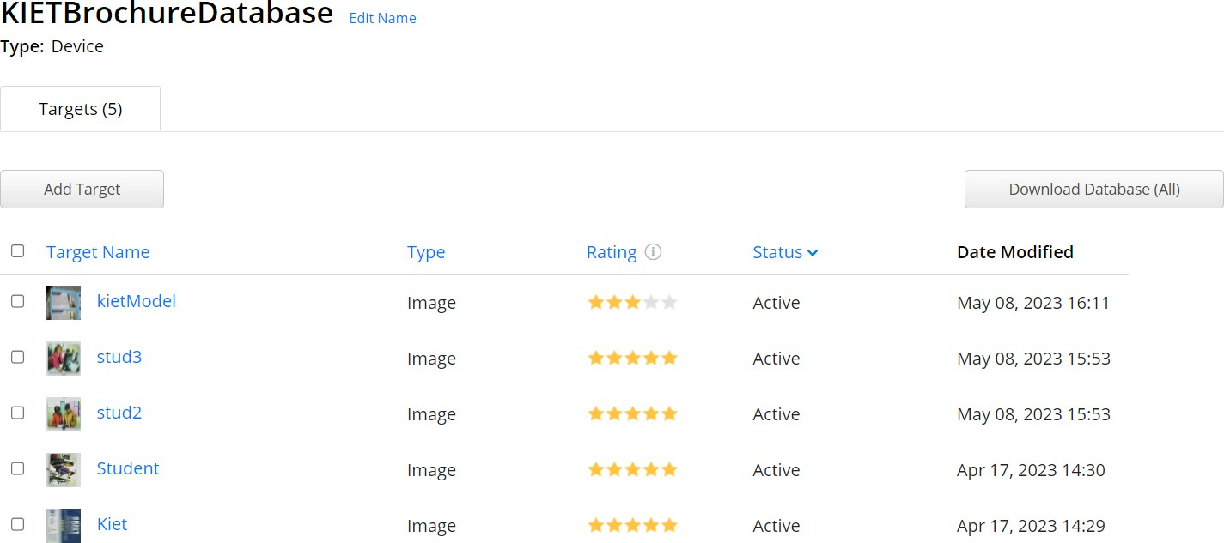

**Fig 5.1 KIET Brochure Database for storing image target**

The rating field in the Vuforia Target Manager indicates the quality or suitability of an image target for tracking purposes. The rating is typically displayed as a numerical value or a visual representation, such as a star rating system. The rating is based on factors like image clarity, distinctiveness of features, and overall tracking performance. A higher rating indicates a better quality image target that is likely to yield more accurate and reliable tracking results.

The rating helps developers and users identify the most suitable image targets for their AR applications. It assists in selecting image targets that are more likely to provide robust and stable tracking, leading to a better augmented reality experience.

The status field in the Vuforia Target Manager reflects the current state or condition of an image target in the Vuforia database. The status provides information on the processing and availability of the image target for use in AR applications. The status can have different values like processing, active, inactive.

* + - **Feature Extraction and Matching:** The image recognition and tracking module employs feature extraction techniques to identify distinctive characteristics of the image targets. These features can include edges, corners, textures, or other visual attributes. By extracting and analyzing these features, the module creates a mathematical representation, known as a feature descriptor, for each image target. During runtime, the extracted features are compared against the feature descriptors in the image target database, enabling precise matching and identification of the detected image targets.

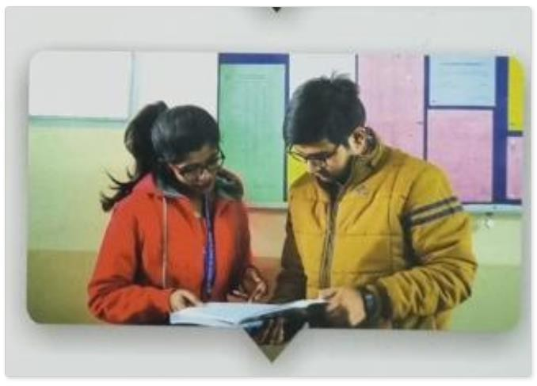

**Fig 5.2 Image Target before Feature Extraction**

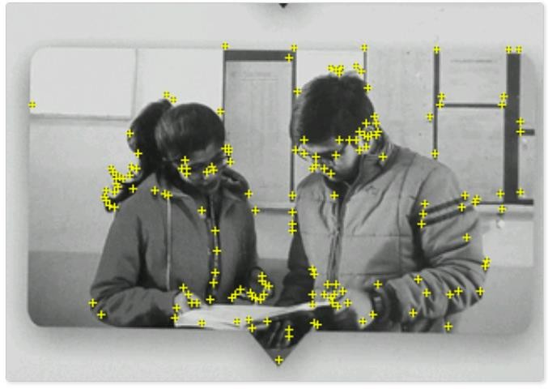

**Fig 5.3 Extracted Feature from Image Target**

* + - **Tracking and Pose Estimation:** Once an image target is recognized, the image recognition and tracking module employs tracking algorithms to continuously track the target's position and orientation in the camera view. This tracking process ensures that the digital content remains accurately aligned with the recognized image target, even as the user moves or the camera perspective changes. The module estimates the pose (position and orientation) of the image target relative to the device's camera, enabling the proper rendering and overlay of digital content onto the real-world view.
    - **Real-Time Updates and Stability:** The image recognition and tracking module is designed to provide real-time updates of the recognized image targets. It constantly analyzes the video feed and identifies changes in the scene to ensure the accurate detection and tracking of the image targets. The module is designed to handle varying lighting conditions, occlusions, and changes in perspective, maintaining stability and minimizing false positives or false negatives during the recognition process.

The image recognition and tracking component, utilizing advanced algorithms and techniques, is the core functionality that drives the seamless integration of digital content in the AR application. By leveraging feature extraction, matching, tracking, and pose estimation, this module ensures accurate recognition and tracking of image targets within the college brochure. The integration of these components enables a dynamic and

interactive AR experience where users can view relevant digital content overlaid on the real-world view, enhancing engagement and providing an immersive user experience.

# CONTENT MANAGEMENT AND RENDERING

Content creation plays a vital role in designing and implementing the digital assets that will be overlaid onto the recognized image targets within the college brochure. Unity provides a robust framework for content creation, utilizing game objects, prefabs, and various other components to build and manipulate the AR experience. Let's explore how these elements contribute to the content creation process:

* + - **Game Objects:** Game objects are fundamental building blocks within Unity that represent entities in the virtual world. In your project, you will use game objects to create and position 3D models, videos, animations, and interactive elements within the AR environment. Each digital asset, such as a 3D model of a building or a video showcasing campus facilities, will be represented as a game object. You can manipulate their position, rotation, and scale to ensure accurate alignment with the recognized image targets.
    - **Prefabs:** Prefabs are preconfigured game objects or collections of game objects that can be reused throughout the project. They allow for efficient content creation by providing a template or blueprint for frequently used assets. In your project, you can create prefabs for commonly used digital elements, such as buttons, menus, or interactive UI components. This approach ensures consistency and streamlines the content creation process, as you can easily instantiate prefabs and customize their properties for different image targets.
    - **Components:** Unity components are scripts or modules that can be attached to game objects to add functionality and behavior. In your project, you will leverage various components to enhance the interactivity and immersion of the AR experience. For example, you can attach scripts that enable user interaction, such as tapping on a 3D model to trigger animations or playing videos. Components like colliders and rigid bodies can be used to enable physics-based interactions, allowing users to manipulate and interact with the virtual content in a realistic manner.
    - **Animation and Particle Systems:** Unity provides robust animation and particle systems that enable you to bring digital assets to life. You can create animations to add movement, transitions, and dynamic effects to the 3D models or other visual elements. For example, you can animate a character model to walk or a logo to rotate. Particle systems allow you to generate dynamic visual effects, such as sparks, smoke, or explosions, which can further enhance the immersion and visual appeal of the AR experience.
    - **Script and Customization:** Unity offers a powerful scripting environment, allowing you to write custom scripts in C# to define specific behaviors and interactions for the digital assets. You can create scripts that control the behavior of the AR application, handle user input, control animations, or

dynamically update content based on user interactions. Scripting enables you to add custom functionality to your AR experience and tailor it to meet the specific requirements of your project.

By leveraging game objects, prefabs, components, animations, particle systems, and scripting capabilities, you will have a wide range of tools at your disposal to create and customize the digital content for your AR application. This content creation process will involve designing and positioning game objects, creating prefabs for reusability, attaching components for interactivity, incorporating animations and particle systems for visual effects, and utilizing scripting to define custom behaviors. By harnessing the power of these Unity elements, you can bring your AR experience to life and provide an engaging and immersive interaction for users with the recognized image targets in the college brochure.

# USER INTERFACE AND DEVICE COMPATIBILITY

User interface (UI) and device compatibility are crucial aspects of your system architecture. These elements focus on designing an intuitive user interface and ensuring that your application is compatible with various devices and platforms. Let's dive into the details of user interface and device compatibility in your project:

* + - **User Interface Design:** The user interface design is responsible for creating a visually appealing and user-friendly experience for your augmented reality (AR) application. It involves designing the layout, navigation, and interactive elements that users will interact with. The UI design should prioritize clarity, simplicity, and ease of use, ensuring that users can intuitively navigate through the application and interact with the AR content. Elements such as buttons, menus, icons, and text should be thoughtfully designed and positioned to enhance usability and provide a seamless user experience.
    - **Responsive Design:** In today's multi-device landscape, it is essential to ensure that your AR application is compatible with different devices, including smartphones and tablets with varying screen sizes and resolutions. Responsive design techniques will be employed to adapt the UI elements and content to different screen dimensions. This involves utilizing flexible layouts, fluid grids, and scalable assets to ensure that the user interface adjusts and renders correctly across a wide range of devices. By implementing responsive design, you can provide a consistent and optimized user experience regardless of the device being used.
    - **Cross-Platform Compatibility:** Your AR application will be developed to be compatible with multiple platforms, such as iOS and Android. This cross- platform compatibility ensures that your application can reach a broader audience and cater to users with different device preferences. By utilizing frameworks and development tools that support multi-platform deployment, such as Unity and Vuforia SDK, you can streamline the development process and ensure that your application runs smoothly on both iOS and Android

devices. This compatibility also extends to different versions of the operating systems, allowing your application to work seamlessly across a range of devices.

* + - **Performance Optimization:** Performance optimization is crucial to ensure that your AR application runs smoothly on various devices. Optimizing the performance involves minimizing resource usage, reducing latency, and achieving a high frame rate. This optimization is particularly important in AR applications where real-time tracking and rendering are involved. Techniques such as efficient memory management, asset optimization, and code optimization will be employed to deliver a responsive and immersive AR experience across different devices and platforms.
    - **User Accessibility:** Considering user accessibility is important to ensure that your AR application is inclusive and can be used by individuals with diverse needs. This involves incorporating accessibility features, such as support for adjustable font sizes, color contrast options, and compatibility with assistive technologies. By adhering to accessibility guidelines and best practices, you can make your application more accessible and cater to users with disabilities or specific accessibility requirements.

By focusing on user interface design, responsive design principles, cross-platform compatibility, performance optimization, and user accessibility, your system architecture will ensure that your AR application delivers a seamless and engaging experience across a wide range of devices and platforms. This approach will enhance user satisfaction, broaden your application's reach, and provide a positive user experience for all users.

The system architecture and design section has outlined the foundation of the AR application, providing insights into the integration of Unity and Vuforia SDK, user interface design, device compatibility, content management, and rendering. By carefully considering these aspects, the project aims to create an immersive and user-friendly AR experience that captivates and engages users. The next section will delve into the development and implementation phase, detailing the steps taken to bring the conceptualized system architecture to life.

# CHAPTER 6

**IMPLEMENTATION AND RESULT**

In the development of an augmented reality project, various methodologies can be employed. This chapter focuses on detailing the implementation of the augmented reality (AR) application, including the integration of Unity and Vuforia SDK, content creation, testing, and the obtained results. It provides insights into the practical aspects of bringing the project to fruition.

# PROJECT STRUCTURE AND ORGANIZATION

The project structure and organization play a crucial role in ensuring the smooth development and maintenance of the augmented reality (AR) project. This topic focuses on establishing a well-defined structure and organization that promotes clarity, efficiency, and collaboration among team members. It encompasses the directory structure, file organization, naming conventions, and version control practices followed throughout the project.

* + - **Directory Structure:** The directory structure outlines the hierarchical organization of project files and folders. It provides a logical and organized framework for storing and accessing project assets, scripts, libraries, and resources. The structure should be intuitive, reflecting the different components and modules of the AR application. Common directories may include "Assets" for storing Unity assets, "Scripts" for storing code files, "Models" for 3D models, "Textures" for textures and images, and "Documentation" for project-related documents.
    - **File Organization:** File organization focuses on how files are named, categorized, and grouped within the project directories. It is essential to establish consistent naming conventions that are descriptive and easy to understand. Meaningful names should be given to scripts, scenes, prefabs, textures, and other project assets to facilitate efficient file management and future maintenance. Additionally, organizing files into relevant subdirectories based on their functionality or purpose further enhances the project's structure and organization.
    - **Naming Conventions:** Naming conventions provide a set of rules and guidelines for naming project elements consistently. This includes naming

variables, functions, classes, scenes, and other components. Consistent naming conventions not only improve code readability but also facilitate collaboration and understanding among team members. It is advisable to follow industry- standard naming conventions or establish a custom convention specific to the project.

* + - **Version Control:** Version control is crucial for managing and tracking changes made to project files over time. It ensures that different team members can work concurrently on the project without conflicts. Employing a version control system, such as Git, allows for easy collaboration, rollback to previous versions, and proper documentation of changes. It is essential to establish a clear workflow for committing, branching, merging, and resolving conflicts to maintain a reliable and organized version history.

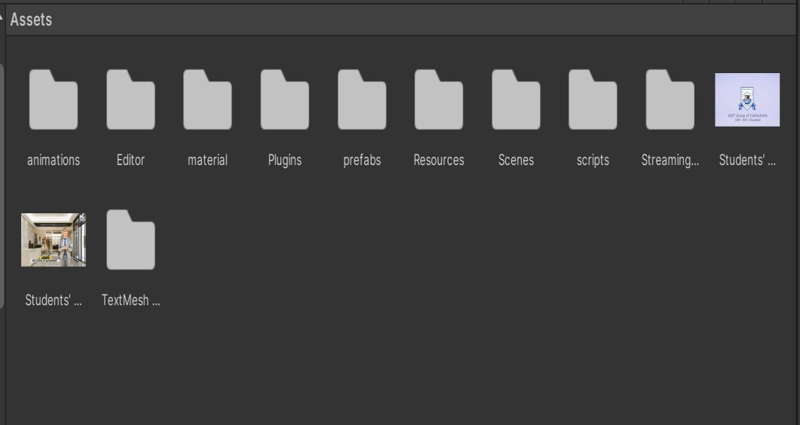

**Fig 6.1 File Organization**

Figure 6.1 shows that file organization of Brochure XR project. In this file structure script, prefabs, material and animations are the created file. Prefabs acts as template from which you can create objects instances in the scene. Material is file that contains information about lighting of an object with that material.

By emphasizing a well-defined project structure and organization, the AR project can benefit from improved code maintainability, efficient file management, easy collaboration, and effective communication. It lays the foundation for a streamlined development process and sets the stage for successful project execution and delivery.

# INTEGRATION AND CONTENT MANAGEMENT

The implementation of the augmented reality (AR) application involved the seamless integration of Unity and Vuforia SDK, along with the creation and management of AR content. The integration process encompassed setting up the development environment, importing the necessary Unity and Vuforia SDK packages, and configuring project settings. Within this integrated environment, the focus shifted to content creation and management, where 3D models, textures, animations, and other assets were designed and developed to overlay digital objects onto recognized image targets. Techniques such as game objects, prefabs, and asset bundles were employed to

efficiently manage and manipulate the AR content. This integration of Unity and Vuforia SDK, coupled with effective content creation and management, formed the foundation for delivering an immersive and interactive AR experience in the application.

# ACTIONS AND SCRIPTING

Scripts play a crucial role in the development of an augmented reality (AR) project, enabling the implementation of various functionalities and interactions within the application. Here are some ways scripts help to make our Brochure XR project successful:

* + - **Image Target Recognition and Tracking**: Scripts can be used to implement the image recognition and tracking capabilities of your AR application. By utilizing the functions and APIs provided by the AR SDK, you can write scripts that detect and track image targets in real-time. These scripts can handle the initialization, tracking, and rendering of digital content on the recognized image targets.
    - **User Interactions and Input Handling:** Scripts allow you to define user interactions and handle input from various devices, such as touchscreens, gyroscopes, or motion sensors. You can create scripts that capture user gestures, touch events, or device movements to trigger specific actions within the AR environment. These scripts enable users to interact with the virtual objects, navigate through the application, or control the AR experience.
    - **Content Creation and Animation:** Scripts are instrumental in creating and manipulating AR content dynamically. You can write scripts that instantiate and position 3D models, apply animations and transformations, and control the behavior of virtual objects. These scripts provide flexibility in customizing the appearance and behavior of digital content based on user interactions or predefined conditions.
    - **Application Logic and State Management:** Scripts play a vital role in implementing the overall application logic and managing the state of your AR project. You can create scripts that handle scene transitions, manage game progress, maintain data persistence, or trigger specific behaviors based on predefined conditions. These scripts ensure the correct execution and flow of the AR application, providing a coherent and engaging experience for users.

In summary, scripts empower us to implement essential functionalities, interactions, and behaviors within our AR project. They enable image target recognition and tracking, handle user interactions and input, facilitate content creation and animation, manage the user interface, and govern the application's logic and state. By leveraging the power of scripting

# TESTING

In an augmented reality (AR) project, there are several types of tests that can be performed to ensure the functionality, performance, and user experience of the application. Here, we used only two test those are performed to check the Brochure XR reliability:

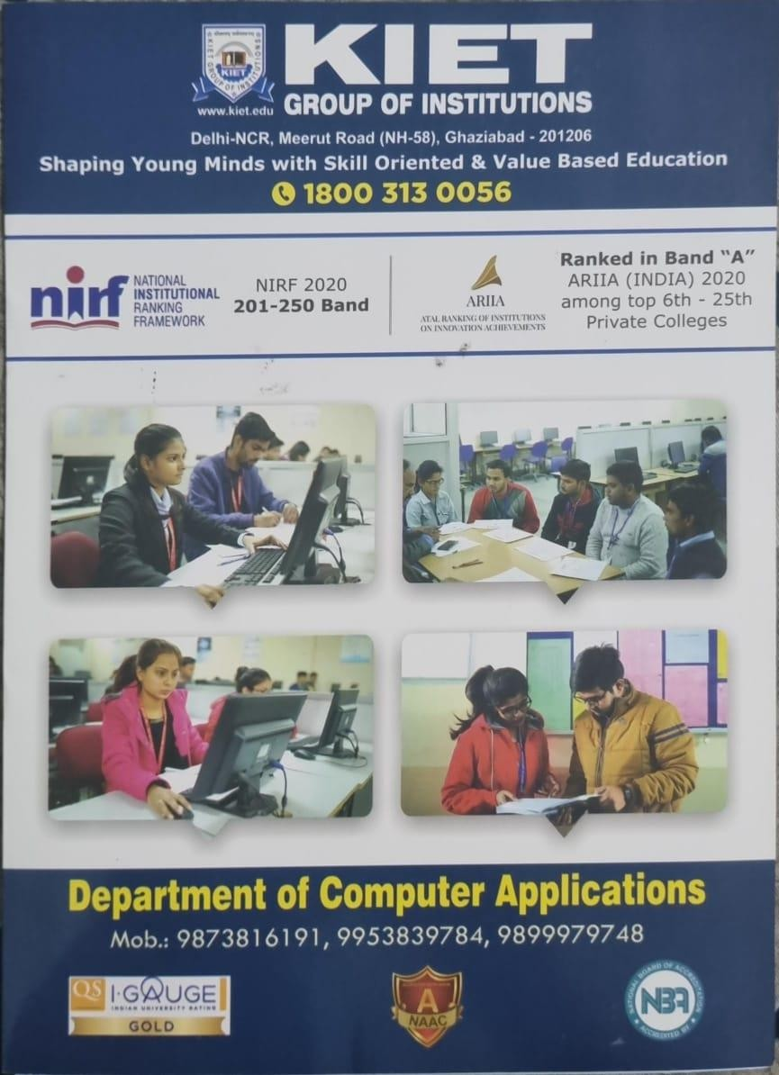

**Fig 6.2 KIET Brochure for Testing**

* + - **Image Recognition and Tracking Test:** The Image Recognition and Tracking Test is a critical component of an augmented reality (AR) project that focuses on evaluating the accuracy and reliability of the image recognition and tracking capabilities of the application. This test ensures that the AR application can effectively identify and track predefined image targets, seamlessly overlaying the corresponding augmented content onto them.

During the test, a variety of image targets are selected from the AR database. Real-world images of these targets are captured using different devices and under various lighting conditions to simulate real-world scenarios. The AR application is then tested to assess its ability to recognize and track these image targets accurately and consistently. The tracking stability, responsiveness, and robustness of the application are evaluated in different situations, such as changes in lighting, distance, and orientation. The primary objective is to verify that the correct digital content aligns precisely with the recognized image targets in real-time.

By conducting the Image Recognition and Tracking Test, any potential issues or inaccuracies in the image recognition and tracking process can be identified. This allows the development team to make necessary adjustments, improvements, or optimizations to enhance the overall accuracy and reliability of the AR application. A successful outcome of this test ensures a seamless and immersive user experience, where the augmented content is precisely aligned with the real-world image targets, providing a captivating and interactive AR experience.



**Fig 6.3 Vertical test of Augmented object in Brochure**



**Fig 6.4 Horizontal test of Augmented Object in Brochure**



**Fig 6.5 When image target is tilted**

**User Interaction and User Interface (UI) Test:** The User Interaction and UI Test focuses on evaluating the user interaction and UI elements within the AR application. This test ensures that users can intuitively interact with the augmented content and that the UI elements are visually appealing, responsive, and easy to navigate.

In this test, key user interactions such as tapping, swiping, pinching, or using device sensors are identified and examined. The application's response to these interactions is tested to verify that they trigger the expected actions or behaviors within the AR environment. The UI elements, including buttons, menus, or information displays, are evaluated for visual clarity, readability, and consistency. The responsiveness and fluidity of the UI elements are also assessed to ensure smooth transitions and animations that align with the overall design guidelines. The objective is to create an intuitive and user-friendly interaction flow where users can seamlessly navigate through the augmented content and access relevant information without any confusion or frustration.

By conducting Image recognition and Tracking and User Interaction and UI Test, any usability concerns or issues with the user interaction flow or UI design can be identified and addressed. A successful outcome of this test ensures that users can effortlessly engage with the AR application, intuitively interact with the augmented content, and find the UI elements visually appealing and responsive, leading to a positive and enjoyable AR experience.

# CHAPTER 9 BIBLIOGRAPHY

1. Nirma Sadamali Jayawardena, Park Thaichon, Sara Quach, Ali Razzaq, Abhishek Behl, ‘The persuasion effects of virtual reality (VR) and augmented reality (AR) video advertisements: A conceptual review’, Journal of Business Research, Volume

160 - 2023,

(<https://www.sciencedirect.com/science/article/pii/S0148296323000978>)

1. Pauline Pfeifer, Tim Hilken, Jonas Heller, Saifeddin Alimamy, Roberta Di Palma, More than meets the eye: In-store retail experiences with augmented reality smart glasses, Computers in Human Behavior-2023 (<https://www.sciencedirect.com/science/article/pii/S074756322300167X>)
2. Panote Siriaraya, Takumi Kiriu, Wan Jou She, Mohit Mittal, Yukiko Kawai, Shinsuke Nakajima, Investigating the use of Spatialized Audio Augmented Reality to enhance the outdoor running experience, Entertainment Computing, Volume 44 – 2023 (<https://www.sciencedirect.com/science/article/pii/S187595212200057X>)
3. Nirma Sadamali Jayawardena, Park Thaichon, Sara Quach, Ali Razzaq, Abhishek Behl, ‘The persuasion effects of virtual reality (VR) and augmented reality (AR) video advertisements: A conceptual review’, Journal of Business Research, Volume

160 – 2023

(<https://www.sciencedirect.com/science/article/pii/S0148296323000978>)

1. Diego Hernandez Arjoni, Ivan de Souza Rehder, José Márcio Pereira Figueira, Emília Villani, Augmented reality for training formation flights: An analysis of human factors, Heliyon, Volume 9, Issue 3 – 2023 (https://[www.sciencedirect.com/science/article/pii/S2405844023013889)](http://www.sciencedirect.com/science/article/pii/S2405844023013889))
2. Merve Yavuz, Eda Çorbacıoğlu, Ahmet Nuri Başoğlu, Tugrul Unsal Daim, Amir Shaygan, Augmented reality technology adoption: Case of a mobile application in Turkey,Technology in Society, Volume 66 -2021 (<https://www.sciencedirect.com/science/article/pii/S0160791X21000737>)
3. Sungjoon Yoon, Jongchul Oh, A theory-based approach to the usability of augmented reality technology: A cost-benefit perspective, Technology in Society, Volume 68 – 2022

(<https://www.sciencedirect.com/science/article/pii/S0160791X2200001X>)

1. Philipp A. Rauschnabel, Barry J. Babin, M. Claudia tom Dieck, Nina Krey, Timothy Jung, What is augmented reality marketing? Its definition, complexity, and future, Journal of Business Research, Volume 142 - 2022, (<https://www.sciencedirect.com/science/article/pii/S0148296321010043>)
2. Jason Crider, Jacob Greene, Sean Morey, Digital Daimons: Algorithmic Rhetorics of Augmented Reality, Computers and Composition, Volume 57 - 2020 (https://[www.sciencedirect.com/science/article/pii/S8755461520300402)](http://www.sciencedirect.com/science/article/pii/S8755461520300402))
3. Ab Rouf Khan, Chapter Nine - Envisioning big data in IoT with augmented and virtual reality: challenges,opportunities, and potential solutions, Editor(s): Samiya Khan, Mansaf Alam, Shoaib Amin Banday, Mohammed Shaukat Usta, Extended Reality for Healthcare Systems, Academic Press - 2023, (<https://www.sciencedirect.com/science/article/pii/B9780323983815000052>)
4. Philipp A. Rauschnabel, Augmented reality is eating the real-world! The substitution of physical products by holograms, International Journal of Information Management, Volume 57 - 2021, (<https://www.sciencedirect.com/science/article/pii/S026840122031478X>)
5. Eunyoung (Christine) Sung, The effects of augmented reality mobile app advertising: Viral marketing via shared social experience, Journal of Business Research, Volume

122 - 2021,

(<https://www.sciencedirect.com/science/article/pii/S0148296320305439>)

1. Ying-Yin Huang, Marino Menozzi, Effects of viewing distance and age on the performance and symptoms in a visual search task in augmented reality, Applied Ergonomics, Volume 102 - 2022, (<https://www.sciencedirect.com/science/article/pii/S0003687022000692>)
2. Saifeddin Alimamy, Juergen Gnoth, I want it my way! The effect of perceptions of personalization through augmented reality and online shopping on customer intentions to co-create value, Computers in Human Behavior, Volume 128 - 2022, (<https://www.sciencedirect.com/science/article/pii/S0747563221004283>)
3. Graeme McLean, Alan Wilson, Shopping in the digital world: Examining customer engagement through augmented reality mobile applications, Computers in Humwhaan Behavior, Volume 101 – 2019

(<https://www.sciencedirect.com/science/article/pii/S0747563219302456>)